DAY 1

1 LAPTOP HISTORY OF PROCESSOR ?
Intel’s 4004 microprocessor ,introduced in 1971, was the first commercially available microprocessor

editor | >
^  complier | > it is used to translate the source code to executable code  There are two types  1 native compiler 2 cross compiler  1 a) working one environment generate the code in same environment  2a) working one environment generate the code per other environment
^  Operating system | > is a fundamental software that mange computer hardware and software resource and provide common service for computer programs
^  processor | > the processor also know as the CPU ,provide the instructions and processing power the computer.

 | Our requirement |  | Other requirement
editor |  | Vi (Visual interface)
Compiler |  | GCC (GNU COMPILER COLLECTION) |  | Kill  / ide
Operating system |  | Linux |  | window
processor |  | Processor |  | processor

Linux => is a free source, hear source code is present , change of source code also available.
Our used linux is command prompt based operating system
Windows => is proprietorship ,only execute the code , hear we does not change any source code , if we need to change any source code , tack permission to owners .
DUPLEX
Duplex
Code |  | > Code

Code < |  | Code
Hear the date transfer code1 to code2 or code2 to code1

Half duplex

Code 1 |  |  |  | Code 2
Date Can only transmitted in one direction at one time
Full duplex
Code 1 |  |  |  | Code 2
Data can be transmitted in both directions on a single carrier at the same time
DAY 2
COMMANDS
Command is nothing but executable file, every command is a one executable file
Some of the commands are:
S.No | COMMAND | DESCRIPTION
1 | mkdir | Create new directory with given name
2 | ls | list the content of Dictionary
3 | cd | change to directory
4 | touch | Create Empty file
5 | cat>filename | create a new file writes content and CTRL+D to save the content into file.
6 | cat | display the content of file
7 | cat file1 file2>file3 | creates new file and content of both files will be copied to new file
8 | ls*.txt | list the files with given extension
9 | pwd | present working directory
10 | cp | copy a file or directory
11 | mv | moves a file or directory
12 | head | Display first 10 lines in file
13 | tail | Display last 10 lines in file
14 | tac | Display the content lines in reverse
15 | more | similar to cat and here we can display large content by using ENTER,SPACEBAR
16 | id | Display id user / group id
17 | clear | clear the screen
18 | vi | text editor to write programs or text
19 | grep | filter to search given pattern in the file content
20 | diff | compares the content of two different files
21 | ping | check the connectivity status of surver …....CONTROL+Z it will be stop
22 | history | review all commands which you have entered
23 | hostname | display hostname
24 | hostname -i | display host ip
25 | chmod | change the user/group permissions to access the file
26 | nl | display the line numbers
27 | wc | given number of lines,words and characters available in the file content
28 | uniq | Removed duplicates of file content/it can remove only continues duplicates
29 | rmdir | removes the specified directory(dictory should be empty)
30 | rm | Remove file

Clear + l = it will clear the screen
1 what is sudo ?
The full form of SUDO is (supper user do) , in the case supervisor only access the code or else.

Commands all are in small letters only
If incase you given capital letters ,that command is not applicable
directory
once install the linux some folders are created those are:
Mnt directory
Root directory

Home directory

Proc directory

Etc directory
Dev directory
Bin directory

Lib directory
/

Linux folder creation is UP to DOWM
/ => called root , under root some folders are
- 1 bin directory
- 2 lib directory
- 3 dev directory
- 4 mnt directory
- 5 etc directory
- 6 proc directory
- 7 home directory
- 8 root directory
Bin directory
- It contains all commands , which are in executable file format
Lib directory
- It contains library files or supporting files
Dev directory
- It contains device driver files
Mnt directory
- It is used to mount the external devices
- Ex : hard disk ……
Etc directory
- It contains network configuration files
Proc directory
- It contains information about processor
Home directory
- It contains all local users

- Root is a privileged user are also called administer user or also called supper user
- Root user control the all local users

FILE CREATION
two
one
C
/
C
Cpp
Ds

Linux

py
Tcpip

Tcpip
Py
Linux

Ds

Cpp
c
V23be10
V23be11
Vbco2
Home

Ex 3 absolute path

Ex 1 absolute path

Path
Reference path

reference path

The linux two types of paths :
- Absolute path :
It is starts with (/), in this path starts with starting home directory
The absolute path is starts on starting directory so number of directory s are more , that time file creation is more difficult . in this case we use reference path
- Reference path :
It is starts with(.) or(...),
(.) it is represent present working directory
(..) it is represent parent directory or move to parent director
The main advantage is
Example :
Of file creation
( 1) Mkdir/home/vbco2/v23be11/ds/one absolute path
2 mkdir ../de/one reference path
3 mkdir ../../v23be10/ds/two reference path
4 mkdir/home/vbco2/v23be10/ds/two absolute path

Day 3
21/05/24

Vi editor
what is vi editor ?

- editor is a piece of paper in computer which is used for writing a program
- we are use one editor that is called “vi editor”
- the vi editor is a command based editor
- vi editor works on two different ways
- Command mode:
Command mode used different ways to operate
- Insert mode:
Insert mode is used only “write a program”
- By default when open a file the” vi” editor is command mode
- If we want to shift “vi” editor form command mode to insert mode press “I”
- If we want to shift “vi” editor from insert mode to command mode press “esc”
- Hidden file starts “.”

Gcc compiler

- the “gcc” based compiler is a command based compiler
- the compiler is used to compile the source code to executable code gcc
- gcc two way’s to compile the code :
1)cc hello.c
2)cc hello.c -o new executable file

cc hello.c cc hello.c -o new exe file

small program

# include <stdio.h>
Void main()
{
Printf(“hello world..\n”)
}

Esc shift+:n = curser is moved to that line
Esc shift+:wq (or) esc shift+zz = save the program and quite
./p1 = run the program (in reference mode)
/home/voco2/v23be11/c/p1 = run the program (in absolute path)
./ = recent present directory
Shift+:q! = without saving quite

RAW code:
Raw code is code with out “OS” on tap of the hard ware directly runs
Cross compiler is generates
Executable code :
Is a code on the tape of the hard ware operating system need to run code
Both are machine understand cods

Compiler are extendedness dependent where has operating system may be may not be

Day 4
23/05/24

Cp hello.c p1.c the “cp” full meaning is copy
Hear we apply “cp” so the file1 data is moved
To file 2
File 2
Copy file 1

Cp hello.c .. /linux hear we apply “cp” to copy the one file1 data o to replace the that data befour directory or file2

copy Be four directory
Or file2
file 1

ls = is used for checking purpose
mv = move directory or file(one place to other place)

mv hello.c hai.c

Cat command:

“Cat” command is used to display the file content on the screen
Using the cat command we can create new file also
But problem is we can not edit middle ,only we can “add” in the end

Using “ cat” command crate the new file:
Cat > abc
…………………
………….enter the some data
Ctrl+d (save and quit)

> = means create file
Cat >> ab
…………………...
………….. enter
data >> = means add the data to previous file

Vi commands :
In command mode
Esc yy = copy (single file)
P = post
3yy = copy (3 lines ,when the curser is there that line to next two lines copy)
dd = delete (curser line is deleted)
3dd = deleted 3 lines (curser is there ,that line to 2 lines deleted)
Y(word starting
Letter) = copy that word
d(word starting
letter) = deleted that word
2d(two words starting
Letter) = 2 words deleted
Esc:%s/hai/abcd = “hai” program is replaced to “abcd”

Basic structure of c program

#include <stdio.h> 1
//global variables
//userdefined function prototypes( declaration)
Void main
{
//local variable
}
//userdefined function definition

There are two types of comments :
1 // single line comments
2 /* multi line comment */

Functions are two types:
User defined
Free defined

What is header file contains ?
The header file contains free defined functions declarations (photo type)
Ex: printf
Scanf

Functions are:
- 1 Function declarations
- 2 Functions call
- 3 Function definition

Why we need to include header file ?
Has per c programing stranded be four call ding any function it should be declare

Day 5
24/05/24

1 What is main ? with out main we can write a “ c program” ? why main?
- Main is the function
The program execution starts particular point that point is called main,
Normal compilation with out main error is come , so use the some other command “ cc -nostartfile (file name)” , without this command error is came

2 can we write a “ c program “ with out any function ?
- No , minimum one function is present

3 can we write with out main function?
- Yes, in “gcc” but we need to compile in different way

Compilation stages (or) compilation steps

Source code .c

Compiler

Execution code a.out

Source code “ .c”

.c
Preprocessor

.i

Translator

.s

assembler

.o

Linker

compiler
a.out
Execution code “a.out”

In side the compiler some stages are there :
- Preprocessor
- Translator
- Assembler
- Linker

Preprocessor:
Input: “.c “ (source code)
Output: “.i”
Preprocessor generates :
- Header file inclusion
- It will remove comments
- Macro replacement
- Conditional compilation
Command:
$ cc -E (file name).c -o (file name).i
Processor know with header file it need to include whare it will include?
- In “c” file we are working which header file we need to include
Translator:
input: “.i”
output: “.s”

translator generates:
- check the syntax errors
- convert “c program “ into “ASM”
command:
$ cc -S (file name ).i -o (file name ).s

Assembler:
Input: .s
Output .o
Assembler generates :
- Convert “ASM” into “opcodes”
Commands:
$ cc -c (file name).s -o (file name).o

Linker:

Input: .o
Output: a.out
Linker generates:
- Link with libraries
- Add “OS “information
Command:
$ cc (file name).o

Some other commands:
cc -s (file name).c this command we are informing to the compiler stop compilation after translator
cc -c (file name).c this command we are informing to the compiler stop the compilation after assembler
day 6
25/05/24

Errors in c – program

Compile time errors run time errors
- Compile time errors are generated by the compiler
- Run time errors are generated by “OS” (operating system)

Compile time errors:
- Preprocessor error
- Translator errors
- Linker errors
Run time errors:
- Segmentation errors
- Floating point exception errors
- Bus errors
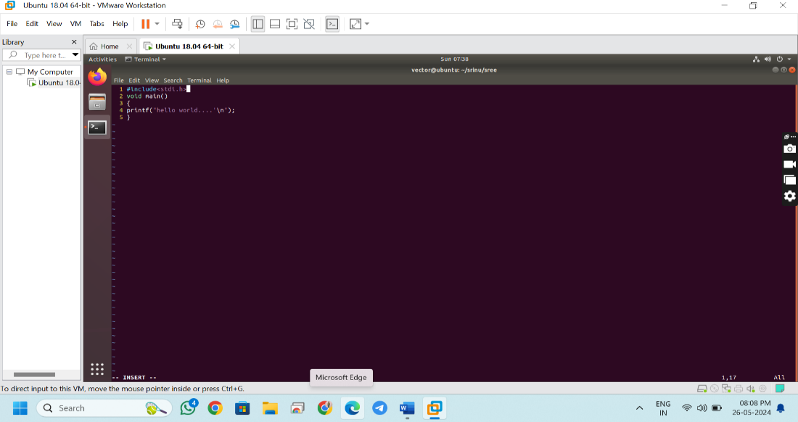
Preprocessor error:
Ex:
vector@ubuntu:~/srinu/sree$ cc srr.c
srr.c:1:9: fatal error: stdi.h: No such file or directory
#include<stdi.h>
^~~~~~~~
compilation terminated.
In this error comes in header file so . it is under preprocessor error. FOR example compiling 1 stage (preprocessor stage ) has 3 errors And second stage (translator stage )has 5 errors ,linker stage ha 1 error so, error rectification or seeing is first stage is opened first ,first stage all errors modified or no errors in fist stage then only open second stage errors .then third stage.
- Translator errors:

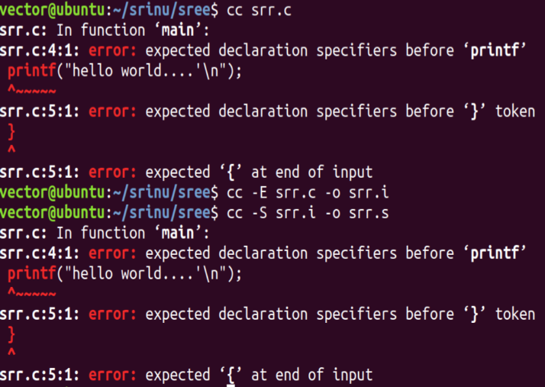
show the side page hear one compilation problem is there , that problem comes “}” missing ,that problem
comes under translator error ,because “}”missing is a syntax problem

for example we don’t know ,witch stage that error came
simply apply first stage command (preprocessor error) command in case same error is come check the preprocessor error generation stages
if incase not generated any error other wise check next command(translator error ) show the side pic be like

- Linker errors:
Without declaring the function if we call the function, translator generates the warning
When calling the function “linker” is searching the libraries’, the linker is responsible for searching function definition, linker searching two places
1 it will searching libraries
2 searching in source code
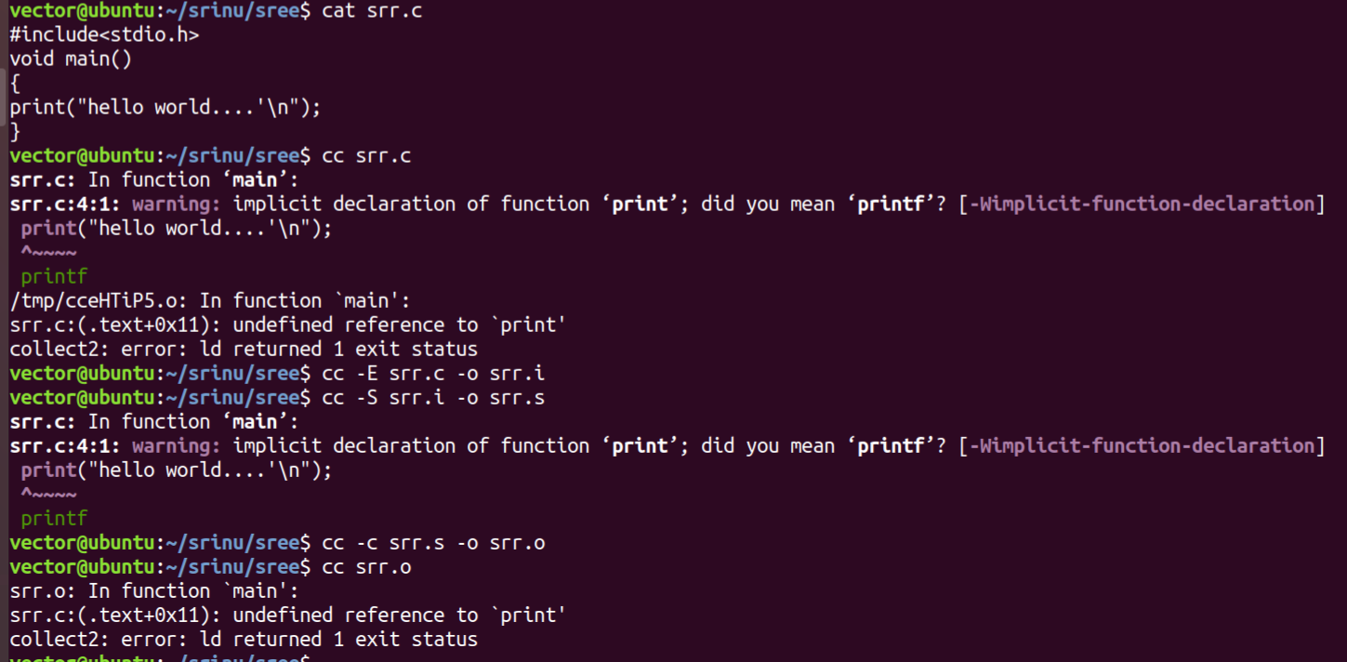
“printf” is a function call in printf “f” is missing , Show the compilation page hear “one warning & one error came , that warning is generated by translator & error is generated by linker ,
See the checking process using command which stage was generated error ,(regarding compilation )
Run time errors:
- Segmentation errors OR unauthorized memory access:

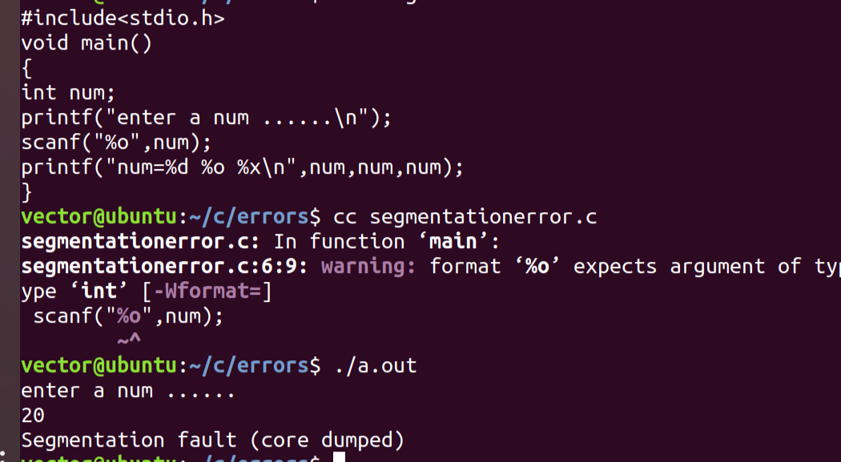
It is also called as unauthorized
In this program came segmentation error , because & is missed in
Scanf statement show the side pic

It is a run time error

a

- Bus errors:

In a ram there is no location
It is hard ware generated where memory is not at all present we are typing to access them

- Floating point exception errors:
It is also call “devide with zero error
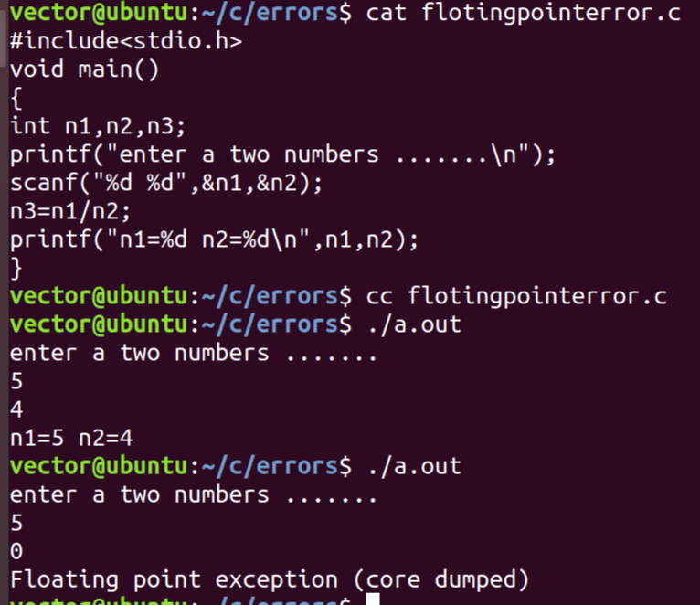

The floating point error is a one of the run time error

N3 =5/4
No error
But incase n3= 5/0 that time floating point error came
That’s why floating point error is also called “devide with
Zero error”

Character data type
(ASCII): American standard code for information interchange
A =65 | a=97 | 0=48
B=66 | b=98 | 1=49
C=67 | c=99 | 2=50
D=68 | d=100 | 3=51
E=69 | e=101 | 4=52
F=70 | f=102 | 5=53
G=71 | g 103 | 6=54
H=72 | h=104 | 7=55
I=73 | i=105 | 8=56
J=74 | j=106 | 9=57
K=75 | k=107
L=76 | l=108
M=77 | m=109
N=78 | n=110
O=79 | o=111
P=80 | p=112
Q=81 | q=113
R=82 | r=114
S=83 | s=115
T=84 | t=116
U=85 | u=117
V=86 | v=118
W=87 | w=119
X=88 | x=120
Y=89 | y=121
Z=90 | z=122
Initialization
Char ch =’a’;
Reserve some name store the ‘a’

Singed range :
-128 to 127
Unsinged range:
0 to 255

day
29/05/24
Integer data types

Char short int long int long long int int
(1 byte) (2 byte) 8 byte 4 byte
(%c = format (%hd= singed %lld = long long singed %d
Specify) short intiger) %llu= long long unsinged %u
(%hu=unsinged
Short intiger)

4 byte 8 byte
32 bit 64 bit
%ld= long singed
%lu= long unsinged

Unsinged (2 byte) 16 bits all are data bits
Short intiger:
Singed (2 byte)16 bits ,” 1” is singed bit ,”15” data bits

Unsinged range:
0 to 65535 or 0 to 2^16-1
Singed range:
The singed ranged is half of the unsinged ranged
-32768 to -1,0 to 32787 or -2^15 to -1,0 to 2^15-1

Long intiger :
There are two types
- 4 byte(32 bits) range:
Unsinged range:
Is
2^32 to 2^32-1 show the bellow pic values

Singed range:
Half of the unsinged range
- 8 byte(64 bite) range:
Unsinged range
2^64 to 2^64-1

show the bellow pic values

The command of all data type family range check:

vi /usr/include/limits.h
after applying the command we get
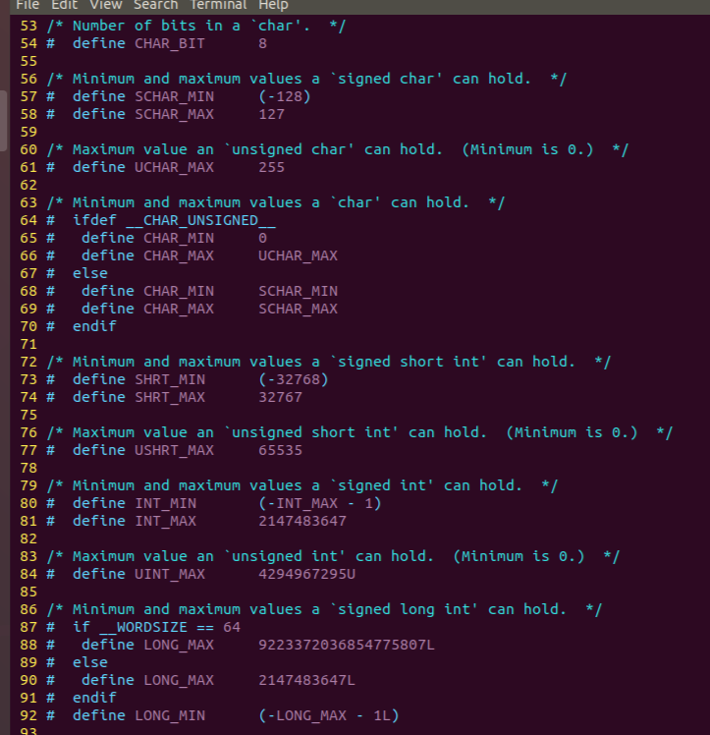

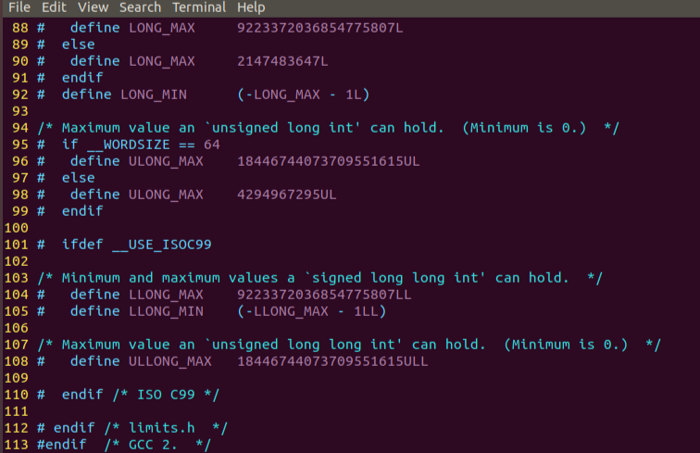

unsinged integer(4 byte) 32bits all bits are data bit
integer

singed integer(4byte) 32 bits ,”1 “ bit is singed bit ,”31” are data bits

unsinged range:
0 to 2^32-1 or 0 to 4294967295

Singed range:
It is a half of the unsinged range
-21474883648 to 21474883647

- %p it is used to print the address

Operators

C = a + b operands

Operator

Operands are three types:
Unary - 1 opend ex: ++1:
Binary - 2 opend ex: c = a + b
Termnary - 3 opend ex c = a+b/9

Operators are two types:
1 Arithmetic operators
2 Assignment operators

Arithmetic operators;

Arithmetic operators

+ - * / %
Assignment operator
=
Relational operators
> >= < <= == !=
Logical operators
&& || !
Bitwise operators
& | ^ ~
shift operators
<< >>
inc and dec
++ --
sizeof()

Reference oeprator(address)
&

dereference operator (pointer)
*
conditional operator
? :
,
+= -=
[] () . ->

Command of operator order of sequence:
Man operator
Show the below page , it is used “which operator first perform the operation” , some rules are:
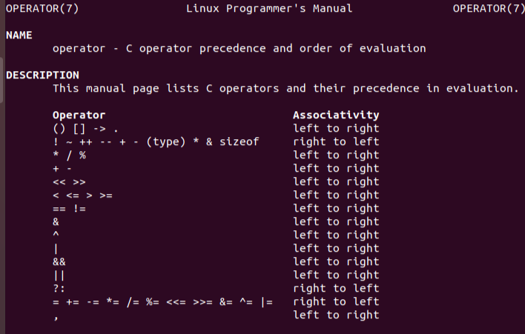
Ex :
R = 10 + 20 * 2 / 30 - 50 ASUME: 20*2 = C
10 + C / 30 - 50 C/30 =D
10 + D - 50 10+D =E
E - 50 E-50 F
R = F

Show the above example hear so many operators there , which operator will perform first that is depends on higher preference and lower preference , that preference show the above pic , considering above example it has more operators are there so ,the higher preference operator “ * ” ,” / “ those are same preference that time check “associativity” , regarding associativity Is left-right so ,first perform operator is “ * “ ,then “ / “ , next high preference is “ + “ , “ - “ show the above pic , this one also same preference so check the associativity,
Any c program mainly contain ?
- Variables
- Functions
- Expression
- Control statements

31/05/2024
Assignment operator
The assignment operator symbol is “ = “
It is a binary operator it required s two operands to perform a task

Op1 = op2
LEFT RIFHT

In operand “op1 “(left) side only accept variables only ,other wise came error, in operand “op2” (right) allow are accept variables, constants , expressions
Variables = I, j, I,…………………
Constants = 20,1,7,……………………….
Expressions = i+r,i+3,9+2………………………..

Small program
1#include<stdio.h> name of the variable “i”
2 void main()
3 { variable declaration
4 int i; expression
5 i = 10; function call
6 printf("i=%d\n",i);
7 }

Write a program for swapping of two numbers
Step2
#include<stdio.h> sri1 sri2
void main() step1
{ step3
int sri1,sri2,pallavi; pallavi
printf("enter a sri1 and sri2 .....\n");
scanf("%d %d",&sri1,&sri2);
printf("befour swap sri1=%d sri2=%d\n",sri1,sri2);
pallavi = sri1;
sri1 = sri2;
sri2 = pallavi;
printf("after swap sri1=%d sri2=%d\n",sri1,sri2);
}

In this program we given” sri1’ one value and ‘sri2’ given two value , that two values inter change by using the swap method
Sri1 given 143 & sri2 given 123
Step 1 in the stage “sri1” value is go to Pallavi block
Step 2 in case “sri2” value go to “sri1”
Step 3 in case “Pallavi” value go to ‘ sri2” show the marked line

Arithmetic operators :
Arithmetic operators are binary operators
Ex:
10 + 10
10+ a
A + 20
A + A
THE difference between “ / ‘ and “ % “
Is

K = 2/13; 2)13(6
12
K = 2%13; 1

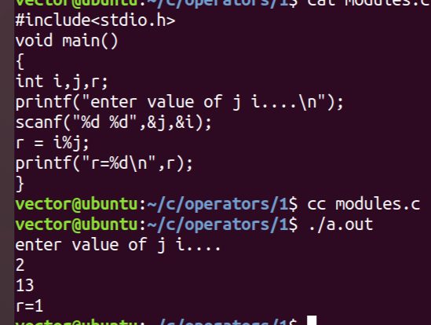
- We can not use modules(/) operator on real numbers, if we use its generates error
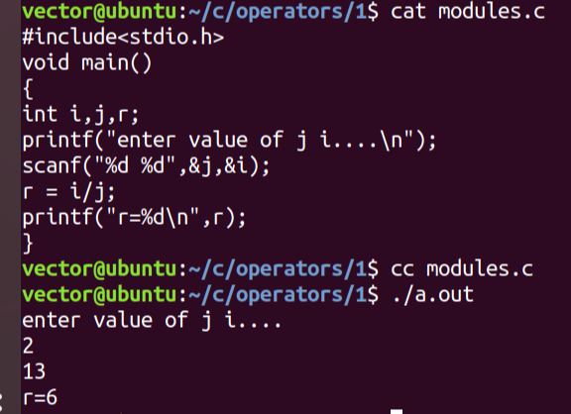 sh

Show the above program pics , the two programs are 99 precent same only changed “/” and “%”

Write a program to print last digit of a given input number

1#include<stdio.h>
2 void main()
3 {
4 int num,r;
5 printf("enter a num......\n");
6 scanf("%d",&num);
7 r = num%10;
8 printf("last digit num %d %d\n",num,r);
9 }
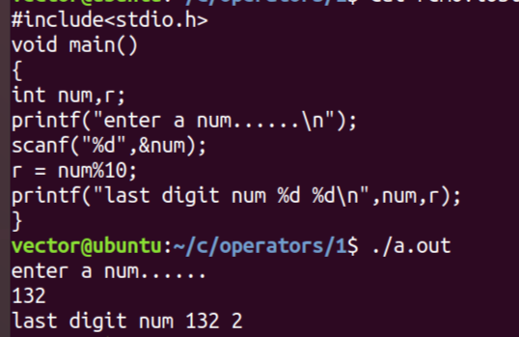
10)132(13
130
2

Hear used “%” so we consider dinominater

Show the above pic hear r = input value%10 so print the out be like
Write a program to delete the last given input number
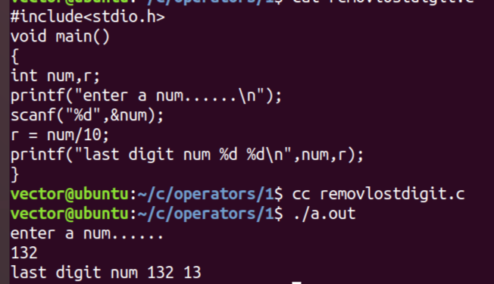

10)132(13
130
2

Show the compile program the above program and this program is same , but only changed “ / “ that’s why we consider consenter

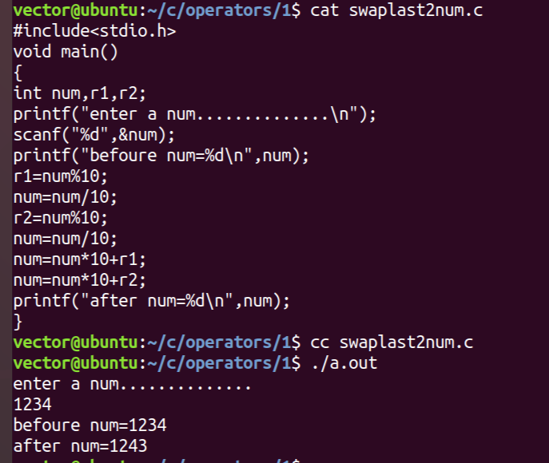
Write a program for swap last two digits of a given input number

r1=num%10; get hold the last num
9 num=num/10; num = num/10; hear delete the last
10 r2=num%10; number
11 num=num/10; r2 =num%10; get hold the last num
12 num=num*10+r1; num= num/10; hear deleted the last
13 num=num*10+r2; number
9 num=num/10; num=num*10+r1;

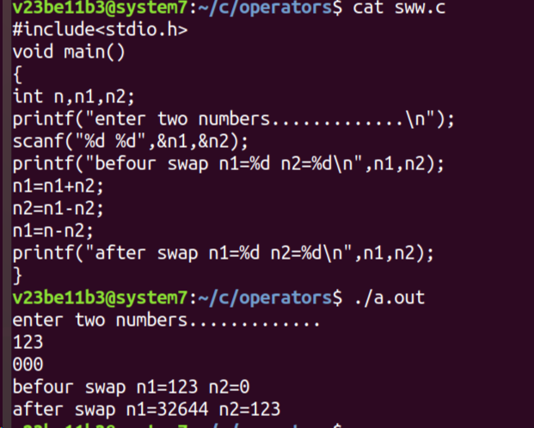
Write a program for swapping of two numbers using arithmetic operators without using any other variable
Hear using the logic or expression is “ arithmetic
“ operators only like”+ -“ show the pic
Ex: given input n1 = 20 n2 =30
n1 = n1+n2; (20+30) = 50
n2 =n1-n2; (50-30) = 20
n1=n1-n2; (50-20) = 30
Show the above expression hear given inputs are
Changed on depending on expression

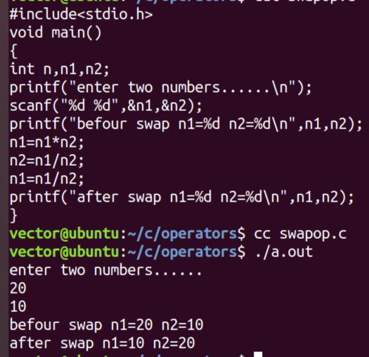
This is also same “swapping program but hear
Changed operator “* , / “ show the pic
Ex: n1=20 n2 =10
n1= n1*n2 (20*10) =200 10)200(20
n2=n1/n2 = 20 200
n1 =n1/n2 = 10 0
20)200(10
200

So depending on
Expression the both inputs are inter changed ,show the
Pic
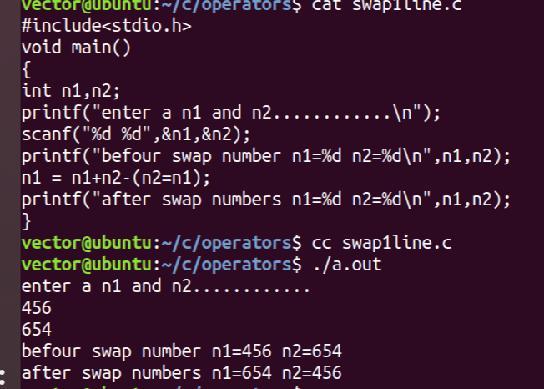
Same swapping program written as a single line expression show the bellow
Show the side program ,the program also same but
Hear used one expression(arithmetic operators),so
This is also one of the swapping program .
That expression in detailed :
n1= 10 n2=20
n1=n1+n2-(n2=n1) ( n2=n1) so 10
n1=n1+n2-exp
n1=10+20-exp
n1=30-exp
n1=30-10
n1=20
So compare to given input n1 and n2 are changed

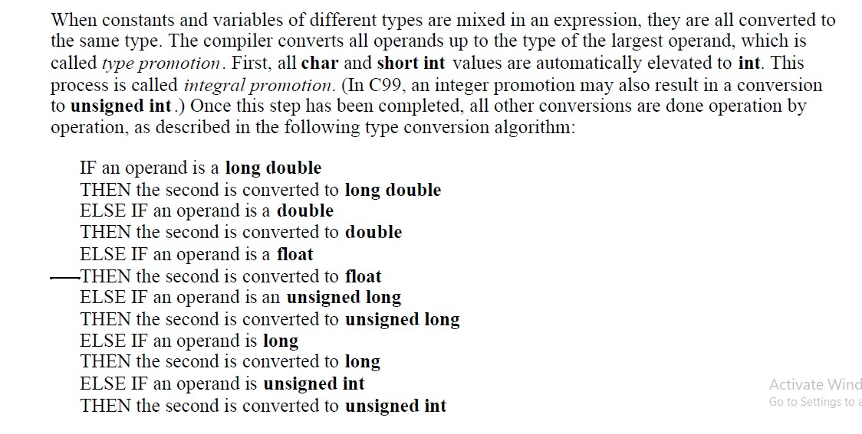
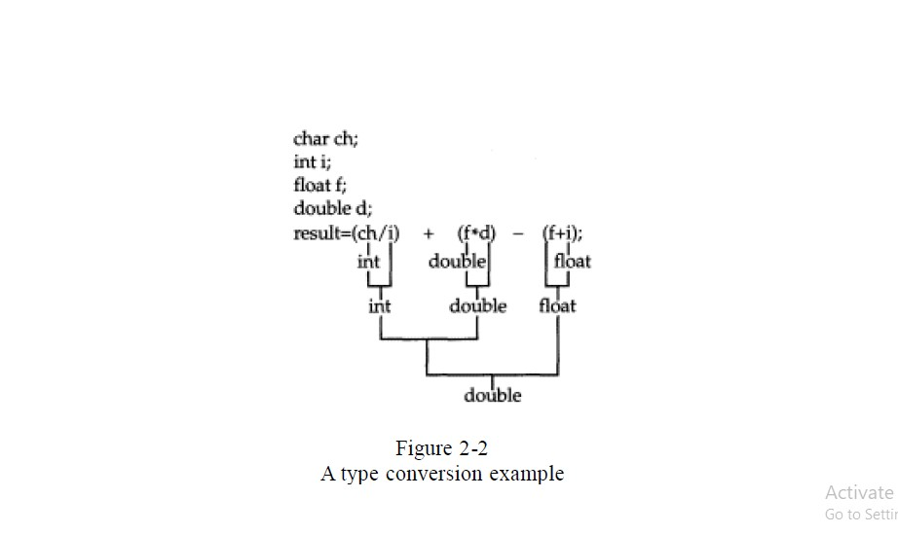
Note: this type conversation only for assignment right hand side only, and also it is temporary conversion

Ex:

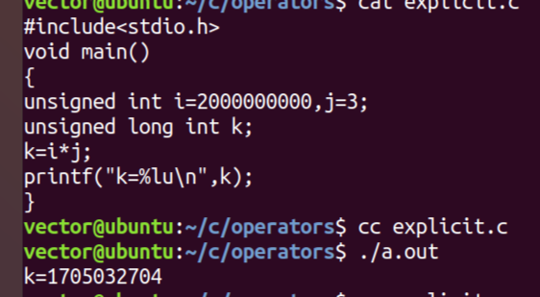
S
Show the side program hear taken unsigned int so
i , j both are consider 4 byte ,the output also 4 byte ,
but k is consider unsigned long int but no use.

that’s why
the out put printed only 4byte

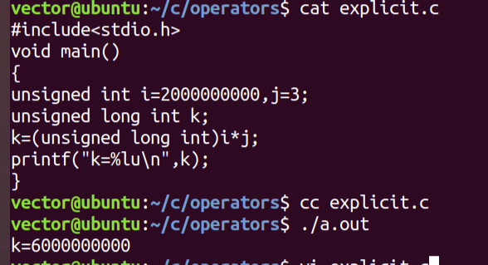
This is also same but hear , input taken unsigned int
So both are 4 byte ,but programmer add some to convert
i is to 8 byte ,that’s why j also converted to 8 byte
the result of output is 8 byte,

this process is called explicit type conversation

who will do explicit type casting ?
programmer
explicit type casting can be lower to higher or higher
to lower

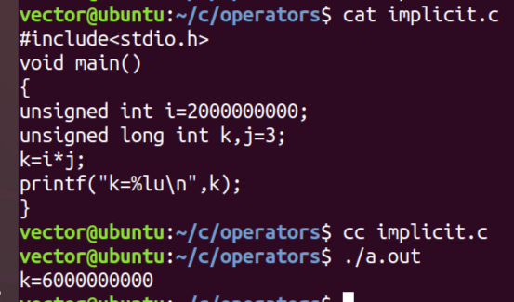
implicating type casting
hear j is directly consider are taken as unsigned unsigned long int so i also converted into 8 byte
,finaly output generated 8 byte
Memory depends on operand size

Who will do implicit type casting ?
Compiler will do
Implicit type casting must be lower to higher

Relational operators: { > >= < <= == !=}

>

>=

<

<=
==

!=
- All those relational operators are binary operators , it means required 2 operand to required do operation
- All the operators will give the result eighter 0 (FALSE) or 1(TURE)

#include<stdio.h>
2 void main()
3 {
4 int o,k,i=10,j=20;
5 k=i<j; k=10<20 condition satisfied so output is”1”
6 o=k>1; o=1>1 condition unsatisfied so output is”0”
7 printf("k=%d o=%d\n",k,o);
8 }
Relational operators are used like TRUE(1) or FALS(0) if condition satisfied print “1” ,if condition fals are unsatisfied print”0”
#include<stdio.h>
2 void main()
3 {
4 int o,k,i=10,j=20;
5 k=i<j>11<9; k=I < j > 11 <9
6 printf("k=%d\n",k); k= 10<20 true so = 1
7 } k= 1>11 falls so = 0
K= 0< 9 true so =1
Finally k=1

/{
9 int i=1,j=-1; hear condition satisfied so output “1”
10 printf("%d\n",i>j);
11
12 result =1

15 /{
16 unsigned int i=1 comparing above program ,hear “I” is consider unsinged so int
17 int j=-1 is treat as a unsigned , so condition unsatisfied output is “0”
18 printf("%d\n",i>j); i>j
19 1>4g =0
20 result = 0

